**PROJECT REPORT OF MINI PROJECT**

**WEATHER FORECASTING SYSTEM**

**In partial fulfilment of requirements for the degree of**

**BACHELOR OF TECHNOLOGY** **IN**

**COMPUTER SCIENCE AND ENGINEERING (AI&ML)**

**SUBMITTED BY: Abhishek kumar**

**ROLL NO. : 2100331530003**

**October 2022(Batch 2022-23)**



**COMPUTER SCIENCE AND ENGINEERING(AI&ML)**

**RAJ KUMAR GOEL INSTITUTE OF**

**TECHNOLOGY, GHAZIABAD(U.P.)**

# Table of Contents

1. Introduction Page No- 2
2. Project Aim Page No- 3
3. Project Specification Page No- 3
4. Deliverables Page No- 5
5. Work Plan Page No- 5-6
6. Use Case Diagram Page No-7
7. UI diagram Page No-8
8. Application Screenshots Page No -9
9. . Limitations Page No- 10
10. Future Aspect Pange No-11

# OVERVIEW

**Introduction**

**Weather forecasting** is the application of science and technology to predict the conditions of the [atmosphere](https://en.wikipedia.org/wiki/Earth%27s_atmosphere) for a given location and time. Weather forecasts are made by collecting quantitative [data](https://en.wikipedia.org/wiki/Data) about the current state of the atmosphere at a given place to project how the atmosphere will change. The role of Technology has been remarkable in the field of weather forecasting

## 2.Project Aim

To make a real time weather application that takes user’s exact location and provides weather forecast for the day and upcoming days also. We also tried to design a simple but visual UI that provides comprehensive data. Also the application provides suggestions to users based on weather conditions. And lastly, user can search and access data for custom locations (string based).

## 3.Project Specification

1. Real time weather forecasting.
2. Takes user’s geolocation as input to provide weather forecast
3. App will predict weather changes with a per minute accuracy based on the user current location.
4. Displays detailed weather information for five cities.
5. Can also take custom location as input to provide weather details for that location (Google Manual Search API).
6. RapidAPI is used to fetch data.

## 5.Deliverables

1. A properly working and executable. File that will run in any device.
2. A documentation that will provide details about the requirements, specifications and other information.

## 6.UseCase Diagram

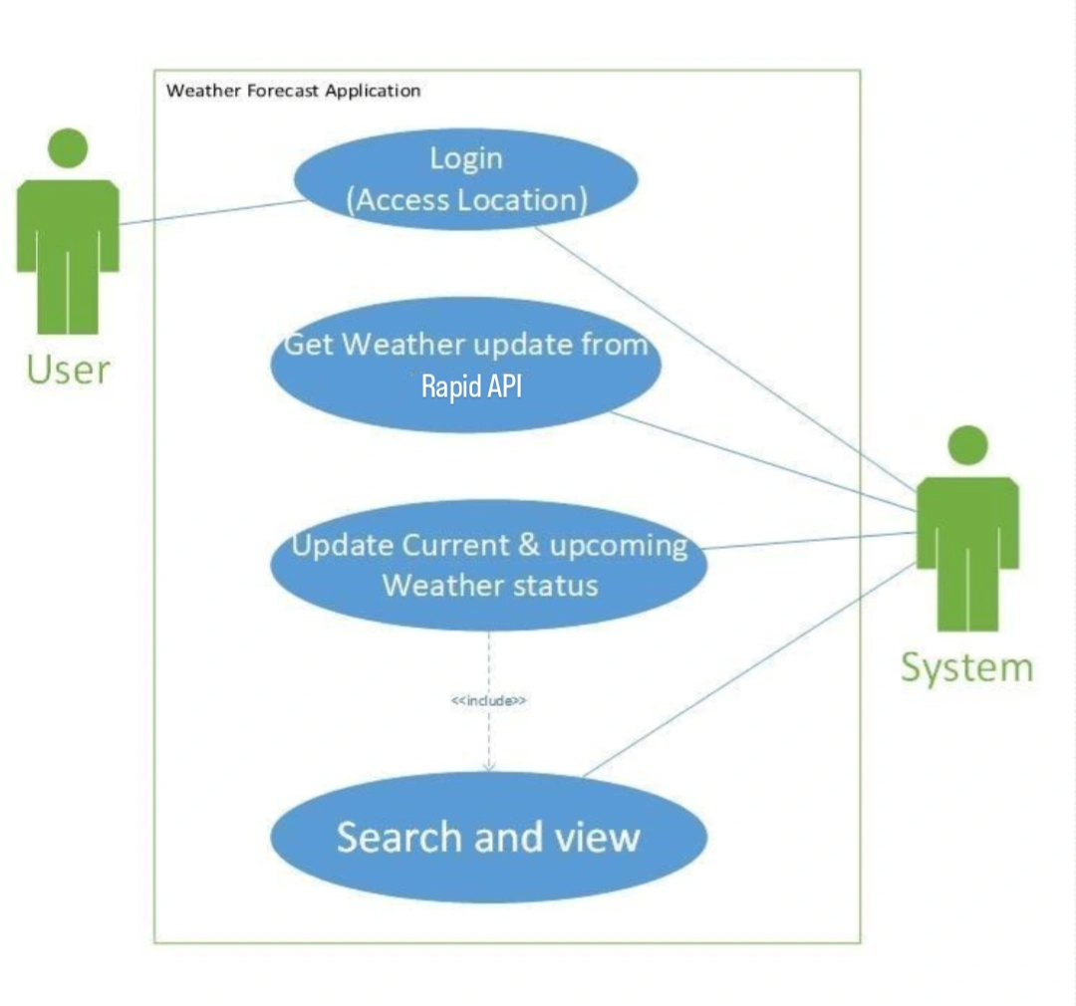

## 8.UI diagram

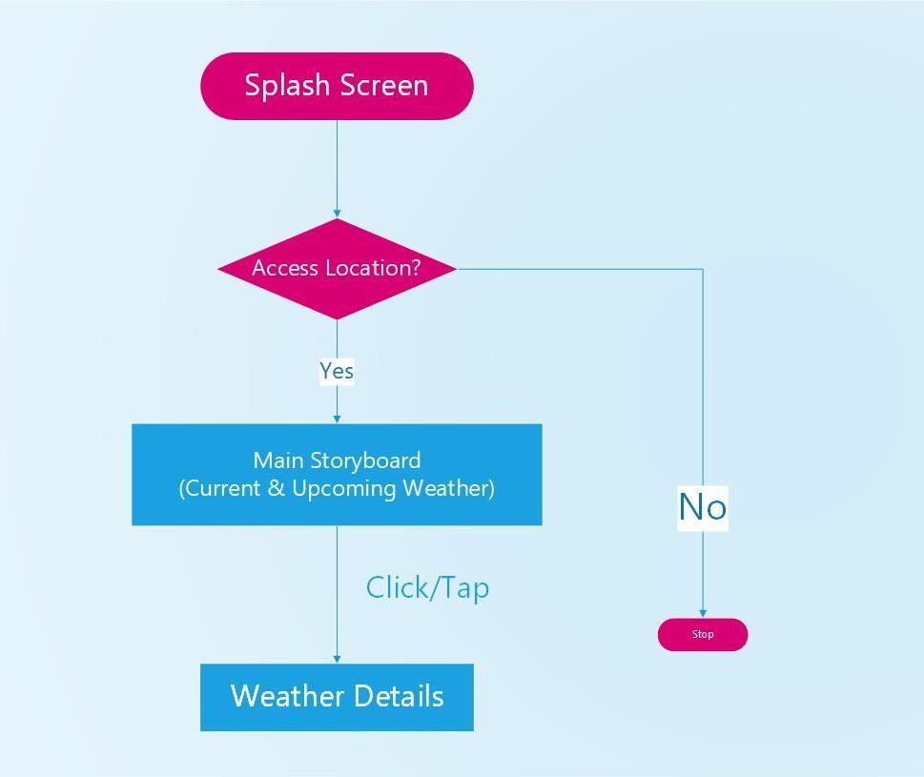

## 9.Application Screenshots

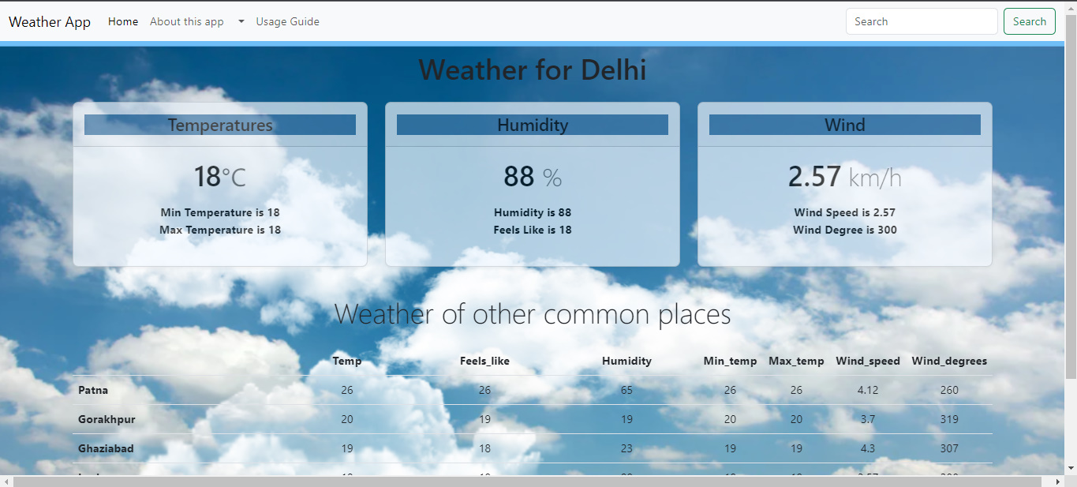

**10.Limitations**

a) Unpaid APIs provide incomplete services. Many details cannot be fetched

b) The GMS API ( Google Manual Search) is actually keyword

based that might only provide data of few discrete locations. The data might not be precise and continuous

c)Language diversity could have been implemented. Multilingual apps make it easy for users worldwide

**11.Future Aspect**

a) We intend to provide more detailed tips based on the age, gender, region and health conditions (Dust allergy, heatstroke tendency etc.) of the user.

b) Recording User inputs to understand the user preferences and providing them necessary notifications needs to be kept in mind.

c) Maybe someday in the near future, we will use AIs for more precision and accuracy.